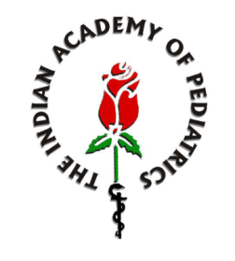
“An Appeal to All Pediatricians and Members of Indian Academy of Pediatrics”
Dear All,
As you know India has become wild polio-free in January 2011, and is now on the verge of certification of polio eradication. Since we have actively participated in all polio eradication related activities of the Government of India (GoI)/NPSP in the past; it is our utmost duty to strengthen the ongoing program in the final stages. Hence, friends we humbly urge all of you to please ensure the following:
- Any child brought for immunization should not leave your facility without receiving a polio dose, OPV or IPV, if indicated by the schedule!!
-We must encourage administration of all OPV doses during the ongoing campaigns, NIDs or SNIDs of GoI/NPSP;
-We should avoid discussion on the sensitive issues like VAPP with parents, media personnel or at any non-academic public forum;
-The current IAP recommendations on polio immunization are one suggested way to the practitioners on how to best utilize available polio vaccines (OPV and IPV) in their office practice. However, they may use even GoI schedule in a given child, if earlier is not feasible;
-We should continue to report all AFP cases to designated authority since AFP surveillance is a critical component of GPEI and essential to rapidly detect poliovirus circulation/importation in the country;
-Please strengthen ‘Universal Program of Immunization (UIP)’ of GoI by reporting adverse events following immunization (AEFI) to the designated authority or to IAP’s IDSurv;
-We must also aggressively counteract any misinformation campaign against vaccines and vaccination programs in the media.

Thanking you,
Sincerely,
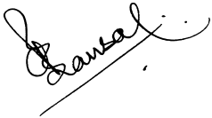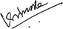
Dr. C. P. Bansal Dr. Vijay N. Yewale
President, IAP President Elect, IAP

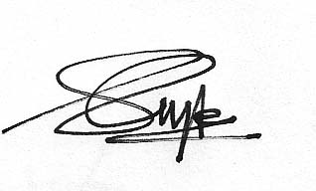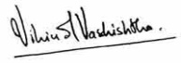
Dr. Sailesh Gupta Dr. Vipin M. Vashishtha
Hon Secretary General Convener, IAP ACVIP

